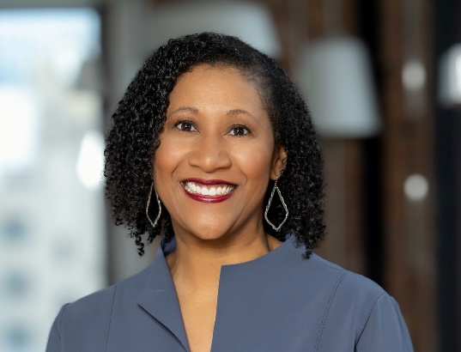 | Dorri C. McWhorter  President and Chief Executive Officer  YMCA of Metropolitan Chicago  1030 W. Van Buren Street  Chicago, IL 60607  dmcwhorter@ymcachicago.org  Twitter & Instagram: @ymcachicago @chicCPA

Dorri McWhorter became President and CEO of YMCA of Metropolitan Chicago in August 2021. Prior to joining the YMCA, Dorri served for 8 years as the CEO of YWCA Metropolitan Chicago transforming the organization from a traditional social service organization to 21st Century social enterprise. Increasing impact and organizational sustainability, YWCA Metropolitan Chicago’s operating budget grew from $10.5 million in 2013 to a $38 million operating budget for FY 2022. The organization has been an active contributor to many critical initiatives across the region, and under Dorri’s leadership, YWCA Metropolitan Chicago expanded its service footprint to 10 new locations, completed seven mergers and acquisitions, implemented paid family leave and developed a retirement plan to include retirement options for thousands of childcare providers and small business owners. Dorri led the effort to develop an exchange traded fund (ETF) for women’s empowerment (NYSE: WOMN) in partnership with Impact Shares, which is the first non-profit investment advisor to develop an ETF product. Dorri is a 2019 Inductee in the Chicago Innovation Hall of Fame.

Dorri prides herself on being a socially-conscious business leader and is committed to creating an inclusive marketplace by leveraging a cross-sector approach of engaging business, civic and community partners. Dorri has a breadth of professional experience across a variety of businesses and industries. She was a partner at Crowe Horwath, LLP, one of the largest accounting firms in the U.S.. She also held senior positions with Snap-on Incorporated and Booz Allen Hamilton. Dorri serves on the Board of Directors for Green Thumb Industries, Lifeway Foods, William Blair Funds and Skyway Concession Company (Chicago Skyway). Dorri is also active in the accounting profession and serves on the Financial Accounting Standards Advisory Council and having served as a member of the Board of Directors of the American Institute of Certified Public Accountants (AICPA) and a past Chairperson of the Board of Directors for the Illinois CPA Society. Dorri serves as Co-Chair of the Advisory Board of the First Women’s Bank (in development).

Dorri’s civic and philanthropic leadership includes the board of directors for Common Impact, 1871 (Technology Business Accelerator), Chicago Council on Global Affairs, Civic Consulting Alliance, Civic Federation, Chicago Center for Arts and Technology, and Forefront. Dorri received a bachelor of business administration degree from the University of Wisconsin-Madison, a master of business administration degree from Northwestern University’s Kellogg School of Management, and an honorary Doctor of Humane Letters from Lake Forest College.

About the YMCA of Metropolitan Chicago
The YMCA of Metro Chicago is an association of 14 Y centers, five overnight camps, and dozens of extension sites located in the city and across the suburbs. We serve more than 200,000 members annually and help children, families, and communities learn, grow, and thrive through programs that promote academic readiness, character development, violence prevention, and fitness and healthy living. Our impact is felt every day when an individual makes a healthy choice, when a mentor inspires a child, and when a community comes together for the common good. Learn about how the Y is working for a better us at ymcachicago.org and to support our work as a nonprofit organization, visit ymcachicago.org/donate.

