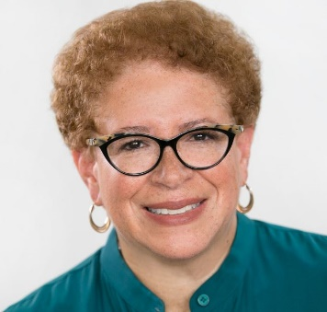
Allison Grant Williams

Allison is an Independent Board Director for Select Sector SPDRs, the 11 sectors of the S&P 500 ETFs; Advisory Board Member for Cresset, a privately held multifamily office & private wealth management firm with $23B AUM for clients nationally; Leadership Advisory Committee Member for The Art Institute of Chicago; Board of Trustees, Columbia College of Chicago; and President, Harvard Business School Club of Chicago Social Enterprise Initiative Fund
Allison’s corporate experience includes COO, Global Funds Services; CMO/CAO, ETF Group; CAO, Institutional Investor Group, & Practice Executive; Global Strategic Relationship Management – Asset Management of Corporate & Institutional Services for Northern Trust, and Partner, UBS Asset Management (Americas), fka UBS Brinson, Brinson Partners, Inc., First Chicago Investment Advisors.

